***What is the HEMIGARD® device?***

The HEMIGARD® device supports skin closed with conventional sutures during surgery and while your wound is healing. It prevents the suture from cutting into the skin and has benefits on the blood supply to the healing wound when compared with conventional sutures.

***How do I care for the HEMIGARD® device?***

The HEMIGARD® device must remain adherent to the skin. **WATER** from any source (sweat, bathing, showering, pools, hot tubs, creams, lotions and ointments) will **WEAKEN** adhesion of the HEMIGARD and adversely affect its performance. Therefore, it is very important to keep your wound **DRY** for at least 5-7 days following surgery or as directed by your surgeon.

You may be asked to keep your operative dressing in place until your follow up, or to change it periodically. In both cases, **KEEP THE DRESSING DRY AT ALL TIMES**.

For wounds on the arm or leg, keep the wound elevated as much as possible and limit exertion.

For wounds on the face, sleep with an elevated head. This may involve sleeping in a recliner or with your head elevated on pillows.

***How will my wound feel and look after surgery? When should I be concerned?***

It is common for your wound to hurt or be sore for a few days after the procedure. You may take acetaminophen (Tylenol) at over-the-counter dosage for pain relief. **AVOID** alcohol, NSAIDs (ibuprofen, naproxen), Ginko Biloba and vitamin E for the first three post-operative days, as these can increase bleeding.

It is common for the wound to have redness around it for several weeks. However, if you develop fever, chills, sweats, red streaking around the wound, swelling under the skin, or yellow or green discharge from the site, please call our office at **YOUR CONTACT NUMBER**.

Ask your provider for directions on use of your regular medications after surgery.

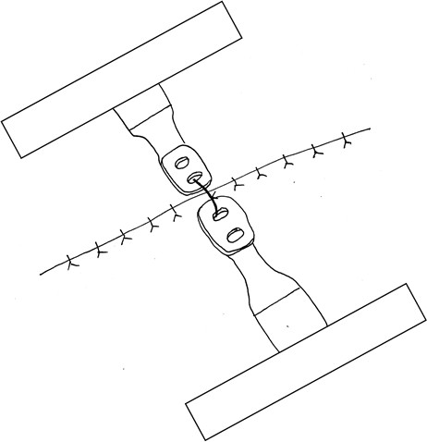

If the ends of the HEMIGARD® strips lift off, then tape them down with bandages (as shown at right).

**DO NOT CUT OR TRIM THE**

**HEMIGARD® strips**

After your HEMIGARD® device is removed in the office, there may or may not be visible sutures, staples or adhesives. Your provider will discuss further wound care.